Vietnam 2026 Macro Outlook



SBV Notes

Vietnam in 2026: FX Stabilisation Sacrifices

Executive Summary  Vietnam enters 2026 with a growth outlook that is resilient but increasingly asymmetric - shaped by solid domestic demand and selective external tailwinds. Real GDP growth is expected to remain robust by regional standards and largely supported by recovering consumption, infrastructure-led public investment, and continued strength in electronics and high-tech manufacturing exports. Tourism has largely normalized while services and construction have regained momentum after post-pandemic dislocations. However, the growth model remains credit-intens ive and externally exposed, thus leaving Vietnam sensitive to shocks originating from global financial conditions and major trading partners.  Inflation dynamics heading into 2026 are relatively benign and largely cost-push rather than demand-pull. Price pressures have been driven more by administered prices and FX pass-through. As a result, the State Bank of Vietnam’s (SBV) reaction function does not primarily target inflation but rather exchange rate stability. As such, instruments used to implement monetary tightening are likely to be diverse - possibly a combination of policy rate adjustments with FX swaps and administrative measures.  Financial stability risks are becoming increasingly salient, particularly through a growing deposit–credit imbalance. Underlying stress is visible in elevated loan-to-deposit ratios, and pockets of asset quality deterioration particularly in real estate and construction. Household and corporate savers have increasingly diverted away from traditional bank deposits toward alternative investments including stocks, gold, and bitcoin.  Externally, Vietnam’s risk profile is dominated by two channels. A slowdown in the U.S. economy represents a material downside risk as the U.S. accounts for roughly one-quarter to one-third of Vietnam’s total exports (concentrated in discretionary consumer goods such as electronics, furniture, apparel, and footwear). Therefore, U.S. demand shock would transmit quickly through several mutually reinforcing factors - including Vietnam’s exports volume, manufacturing employment, household incomes, FDI disbursements, and ultimately domestic consumption. Secondly, the risks associated with Japanese interest rates can trigger capital repatriation and abrupt liquidity withdrawal in Vietnam.  Policy trade-offs in 2026 are therefore unusually acute. The SBV must balance the need to maintain currency stability and external confidence against the risk of over-tightening an economy that remains structurally dependent on bank credit. While maintaining USD/VND stability will remain a priority, this objective would be relatively challenging given Vietnam’s limited FX reserves (covering only around three months of imports) which constraint policy flexibility. | Overview  Real GDP: US$476.3 billion  Real GDP growth (YoY): 7.09%  GDP per capita: US$4700  Inflation: 3.63%  Unemployment rate: 2.24%  Population: 100.9 million  Hoang Minh Tue  saigonequitiesforum@gmail.com |  University of Melbourne  Figure 1: Policy rate  Source: LSEG Workspace  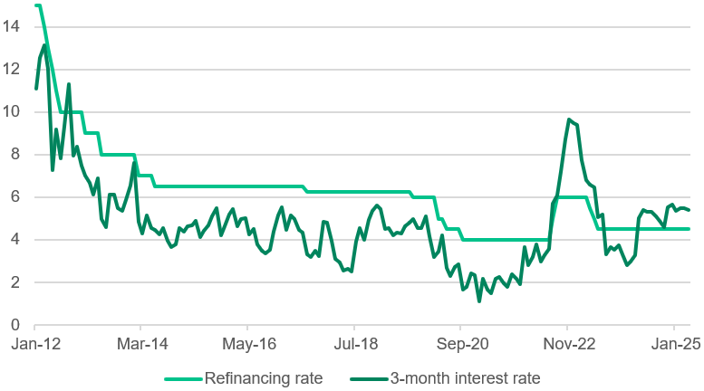  GDP by Sector  Services sector: 42.4%  Industry sector: 37.6%  Agriculture sector: 11.9%  Investment  Total FDI: US$38.2 billion  FDI net inflow: 4.2% of GDP  Total M&A value: US$3.5 billion  Social Indicators  Human Development Index: 0.766  Multidimensional Poverty Index: <1%  Gini coefficient: 0.372

Figure 2: USD/VND  Source: International Monetary Fund (IMF)  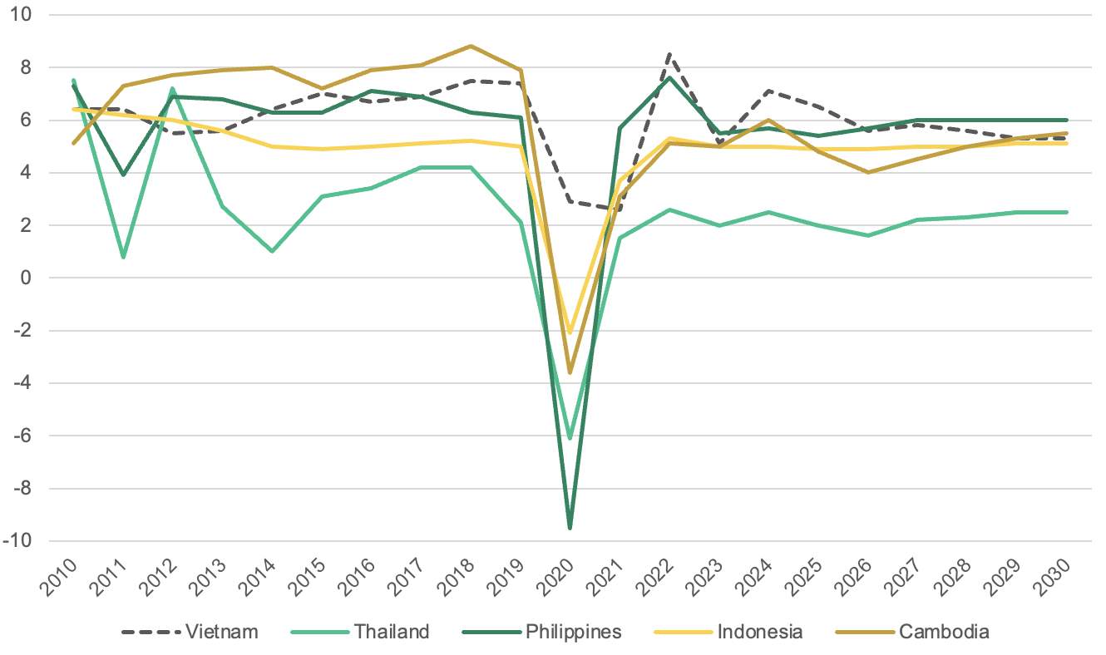  Figure 3: Headline & Core inflation  Source: National Statistics Office (NSO), OECD  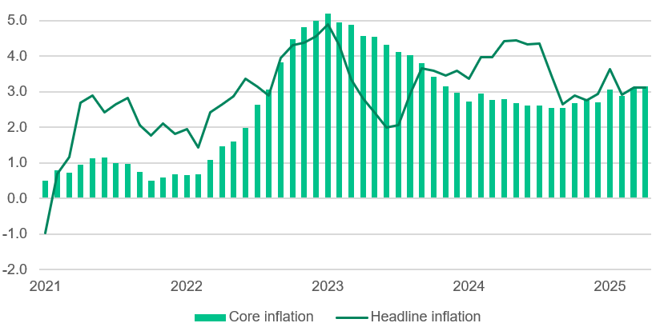  Figure 4: Real wages & Retail sales (YoY %)  Source: OECD  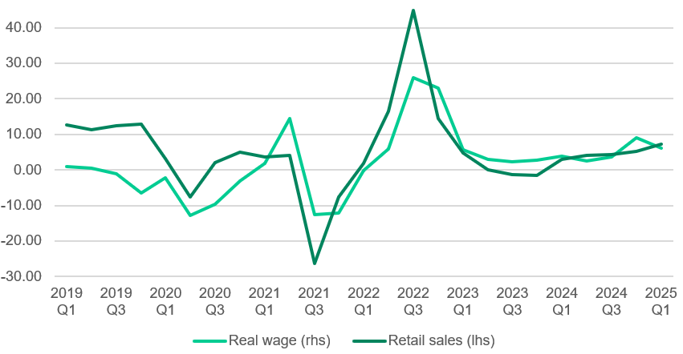  Figure 5: Major public investment projects  Source: International Monetary Fund  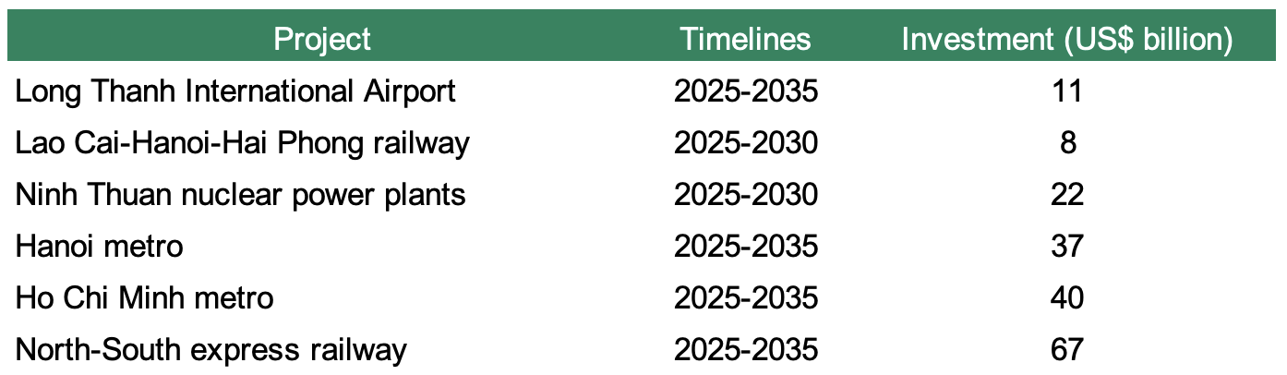 | Recent economic developments  Vietnam economic growth is expected to be driven by domestic demand but partially offset by headwinds from weaker exports and foreign investments in 2026. In recent years, the country has rebounded from negative external and domestic shocks that significantly slowed growth in 2023. From 2020 to 2024, the agriculture, forestry and fisheries sector has contributed steadily to total real output growth in Vietnam. In contrast, the service sector and the construction sector experienced a moderate decline in 2022, before gradually recovering. (KPMG, 2025) In 2025, major growth in electronics and high-tech exports contributed to the 8% rise in real GDP. (NSO, 2025) According to forecasts made by international economics institutions like the World Bank and the International Monetary Fund, it is consistently predicted that Vietnam’s growth would be driven mainly by domestic demand and a rising number of tourist arrivals supporting consumption and investments. The number of tourists entering Vietnam is said to have room to grow and support related industries, as the figure recorded in 2024 was 17.6 million - 2.4% lower compared to the 2019 peak. (OECD, 2025)  In recent years, major public investment projects have been initiated, including the Lao Cai-Ha Noi-Hai Phong railway, the Hanoi-HCM metros, or Long Thanh International Airport. Together with the North-South express railway and two new nuclear power plants in Ninh Thuan, these projects are estimated to require US$185 billion in total investment, equivalent to 40% of Vietnam's 2024 GDP. Although these infrastructure developments carry strong potential in the long run, assessing the macroeconomic implications of such large-scale acceleration in fiscal spending is critical for gauging its short-run economic impact. Looking forward to 2026, continued higher government expenditure and lower tax revenue (automatic stabilisers) would partially offset the negative fiscal impulse from the expiration of earlier one-off spending measures. In the event that downside risks materialise and the economy slows down more sharply than anticipated, further fiscal support could be deployed.  Vietnam heads into 2026 with contained inflation and decent economic growth. Particularly, inflation dynamics reinforce the view that the SBV’s reaction function is not primarily inflation-led at this stage. Headline inflation has been shaped more by food/energy and administered components than by broad-based demand pressure, while core inflation appears consistent with a still-manageable domestic cycle. The implication is that policy tightening in 2026, if it occurs, is more likely to be driven by FX defense, funding conditions and capital flow management than by a need to cool the economy. Due to Trump’s direct tariff, Vietnam’s exports suffered from a great loss of price competitiveness, given that the value-added embedded in exports to the U.S amounts to 10% of Vietnam’s GDP (one of the highest in Asia). Forecast data suggest that growth may slow down to 5.6% in 2026 as the full year of tariffs takes hold and a negative output gap occurs. Given the assumption of limited capacity to diversify international trade or fill in the gaps of U.S. buyers, the current account surplus of Vietnam’s BOP is projected to contract substantially as well as a below target inflation rate.

Figure 6: USD/VND  Source: LSEG Workspace  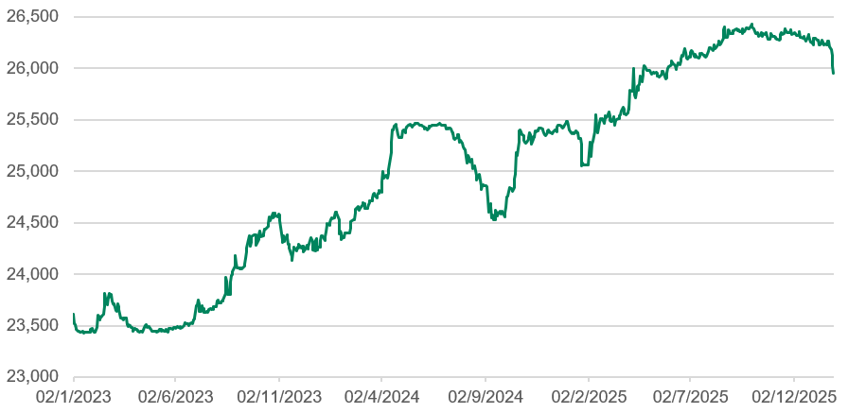  Figure 7: CNY/VND, JPY/VND FX  Source: LSEG Workspace  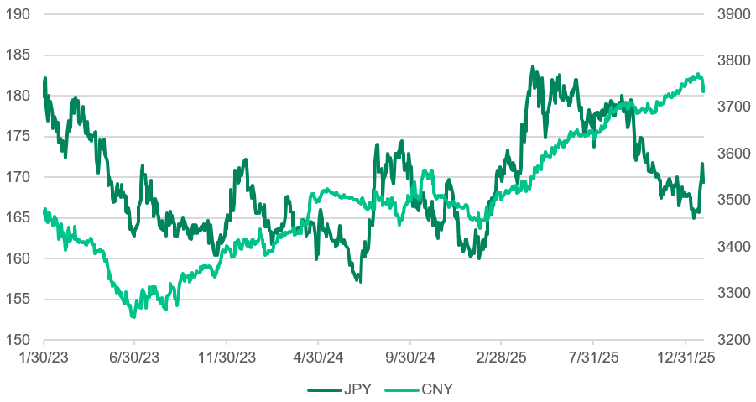Figure 8: Deposit rates (%)  Source: LSEG Workspace  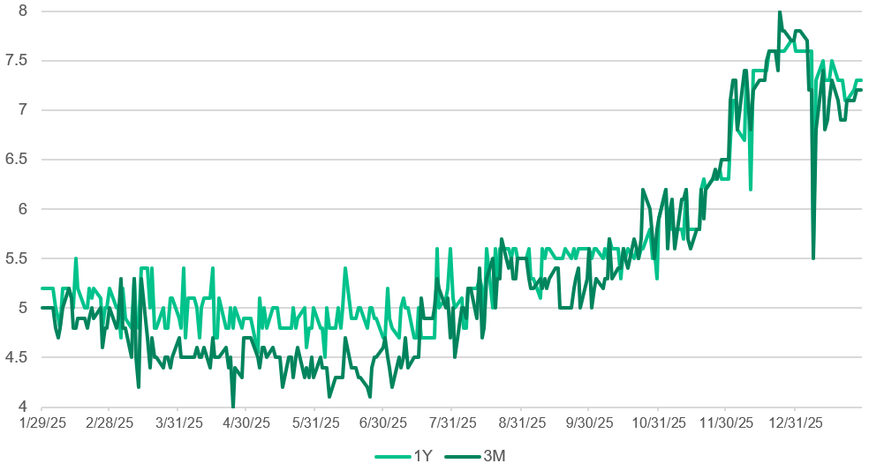  Figure 9: Target vs actual credit growth (%)  Source: International Monetary Fund  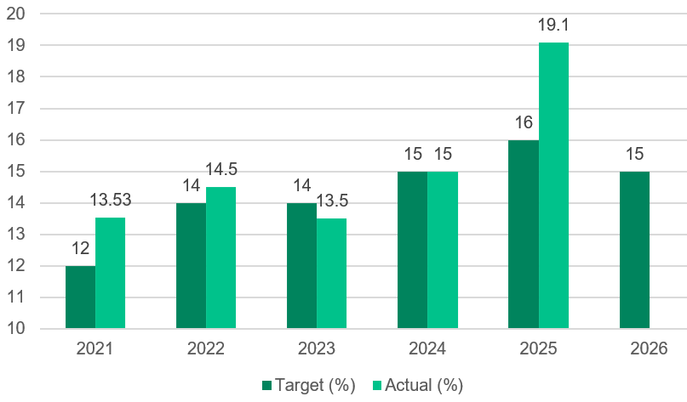  Figure 10: Interbank rates (%)  Source: LSEG Workspace  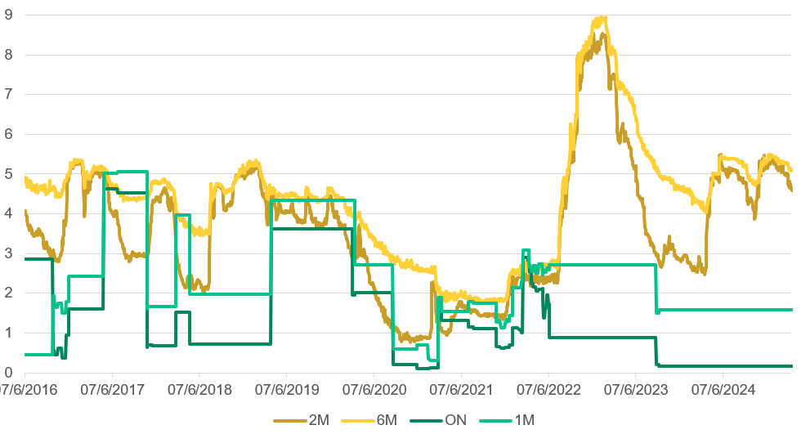  Figure 11: Credit growth vs GDP growth (YoY %)  Source: LSEG Workspace  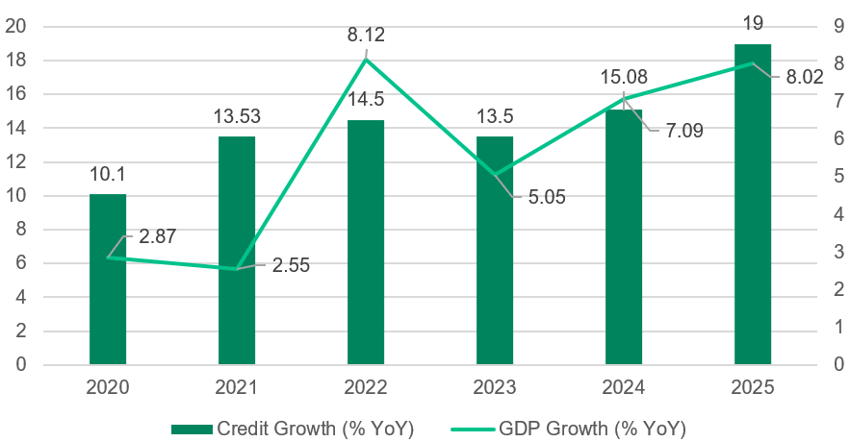  Figure 12: VN Index, gold spot price (US$)  Source: LSEG Workspace  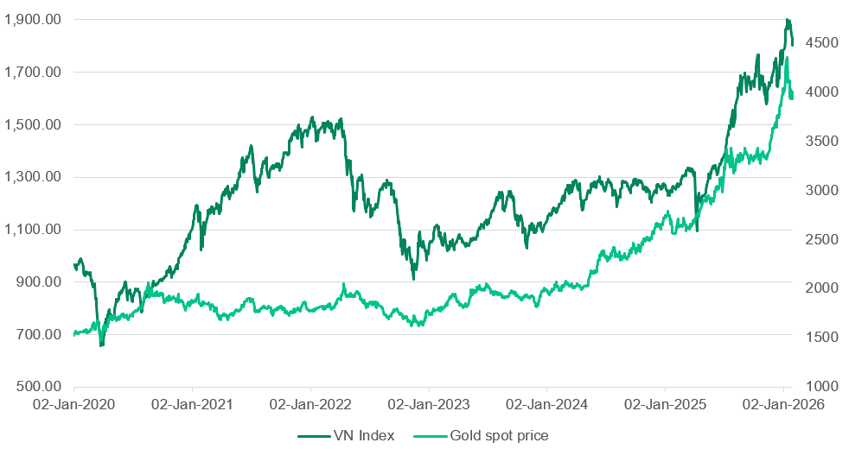  Figure 13: Total reserve, ASEAN  Source: OECD  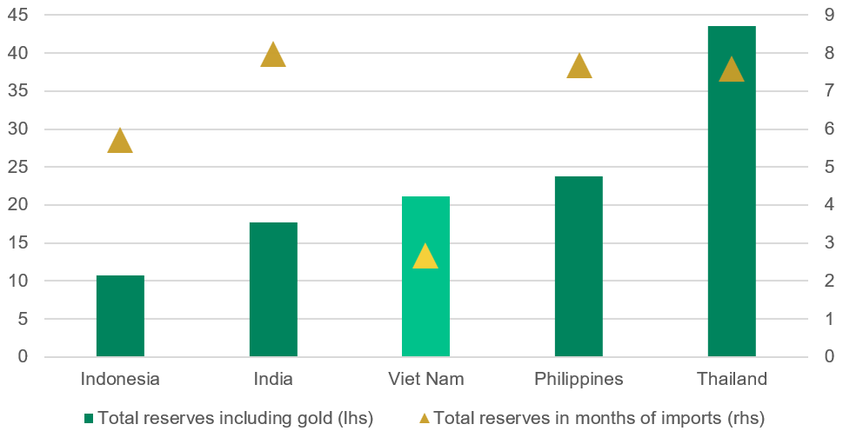  Figure 14: USD/VND FX forward swap  Source: International Monetary Fund (IMF)  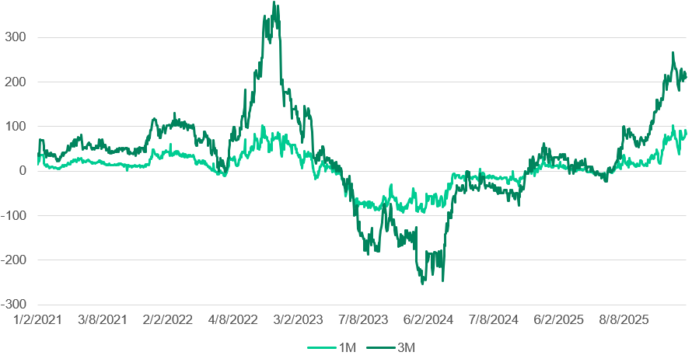  Figure 15: Vietnam OMO framework, market liquidity  Source: LSEG Workspace  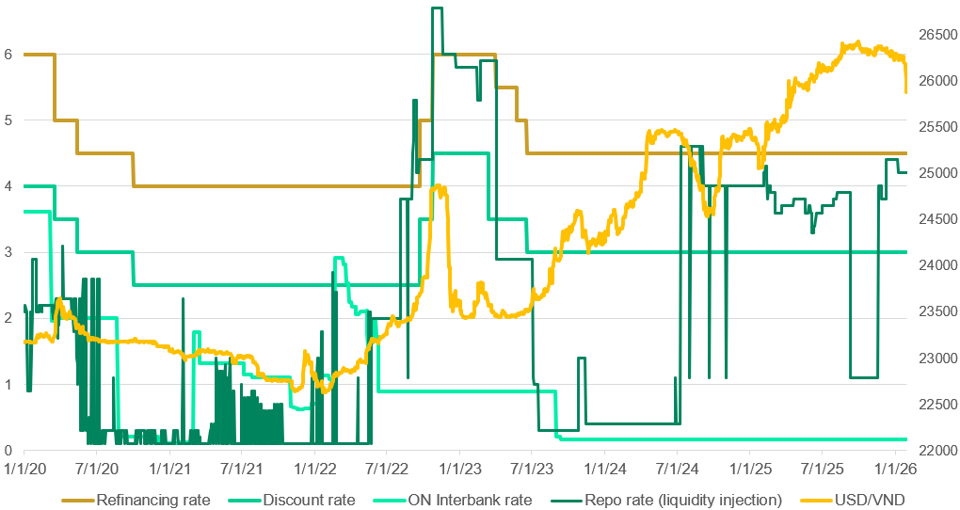  Figure 16: Benchmark yield convergence (%)  Source: LSEG Workspace  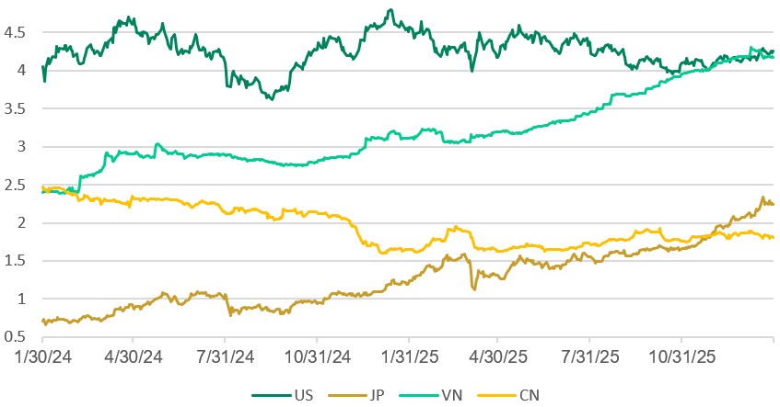  Figure 17: Total reserve in months of imports  Source: LSEG Workspace  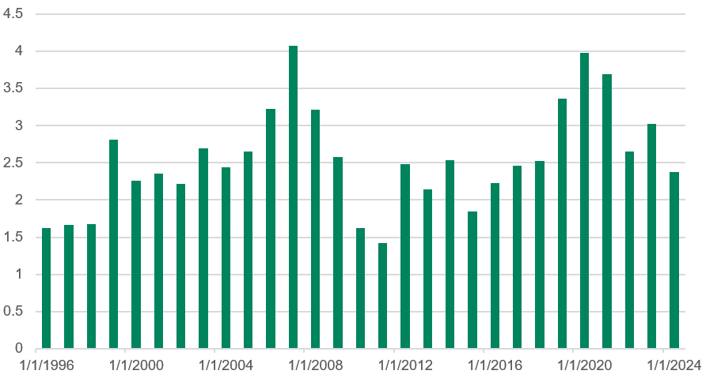 | The 2026 Risks Triangle  Vietnam is highly susceptible to an economy-wide and stock market downturn with respect to several global risks: weaknesses in the U.S. economy, interest rates hikes and risks associated with the Yen. Although Vietnam enters 2026 with a moderately strong narrative, the country’s openness and deep integration into the international supply chain means that downside risks could be asymmetric.  - Japanese Yen risks  While geopolitical escalation appears contained, shocks in the financial market pose more subtle but arguably more immediate risks. Japanese investors hold about US$100 billion in Vietnamese assets - spanning portfolio investments (equities, bonds) and direct investments. An increase in Japan’s interest may trigger capital repatriation - however, the transmission mechanism differs by asset class. In the near term, higher JGB yields are more likely to affect portfolio allocations particularly equities and local currency bonds via rising hedging costs and improved relative returns on domestic Japanese assets. On the other hand, Japanese FDI into Vietnam is structurally driven by long term return consideration and therefore less sensitive to short term rate movements. As such, the primary risk channel is portfolio investment outflow - which may cause depreciation pressures on the VND. Importantly, Vietnam’s domestic interest rate is largely endogenous and driven primarily by the USD, thus limiting the likelihood that a Japanese shock alone would trigger major FX stress or reserve depletion for Vietnam.  - Weakness in the U.S. economy  For many years, the United States has been one of Vietnam’s biggest trading partners. Vietnam’s export share to the U.S. is approximately one-quarter to one-third of the country’s total export (and 30% of GDP), making Vietnam particularly exposed to U.S. demand fluctuations. In a bear scenario where an U.S. recession occurs, Vietnam would be affected through several mutually reinforcing channels. Vietnam’s export basket to the US is heavily skewed toward discretionary consumer goods such as electronics, furniture, apparel, and footwear - categories that historically see double-digit demand declines during US downturns. Weaker orders would lower manufacturing capacity utilisation, particularly in export-oriented industrial zones. Consequently, there would be downward pressures on wages and employment in sectors that occupy a large share of Vietnam’s household income - thus dampening domestic consumption. Lastly, a US slowdown would likely lead to FDI and CAPEX delays as multinational corporations (Samsung, Nike, Apple, etc.) which have driven a large share of Vietnam’s recent $30–40bn annual FDI disbursements - postpone expansion plans amid weaker global demand.  - SBV’s dilemma  While global geopolitics remains a tail risk thanks to Vietnam’s hedging diplomacy which reduces immediate exposure to trade disruptions, Vietnam faces an acute domestic vulnerability tied to interest rates. Vietnam’s stock market is highly sensitive to domestic liquidity conditions, with historical data showing that equity valuations compress sharply once 12-month average bank deposit rates rise above roughly 8%. Given that retail investors account for a large share of market turnover, higher deposit rates tend to trigger rapid portfolio reallocation away from stocks. At the same time, higher funding costs place significant pressure on highly leveraged sectors - most notably real estate, construction and utilities. However, the SBV needs to - at the same time, maintain stability in the USD/VND exchange rate in an environment of elevated global interest rates and volatile capital flows.  Credit and Liquidity  Vietnam’s current credit dynamics highlight a deeper structural vulnerability in its growth model. The amount of credit required to generate incremental GDP is unusually high for an emerging market - for instance, 19% of credit growth in 2025 corresponds with 8% in GDP growth. Vietnam’s weakness in resource efficiency - as pointed out across many annual consultations by the International Monetary Fund (IMF), shows that the country’s growth relies heavily on factor accumulation (labour, capital) and especially bank credit. Particularly, Vietnam’s Total Factor Productivity (TFP) growth has hovered around 0% in recent years. As a result, sustaining high GDP growth increasingly requires greater credit expansion, therefore raising concerns about diminishing returns and asset bubbles. Given these warnings, SBV recently announced the target credit growth for 2026 to be 15% only.  Amid buoyant risk sentiment, household savings were diverted into alternative assets. In 2025, deposit growth (15%) and credit growth (19%) lagged significantly - causing a funding-side stress in Vietnam’s banking system. In essence, liquidity stress is unevenly distributed as state-owned commercial banks (SOCBs) and private banks face different funding conditions. Deposit accumulation has remained relatively stable for SOCBs whereas mid-tier and private banks have faced more pronounced funding pressures. (VNBA, 2026) In particular, liquidity was withdrawn from bank deposits into gold, stocks and bitcoin - which experienced domestic price surges of 70%, 37% and 35% respectively. Importantly, the observed surge in domestic gold, equity, and crypto prices should not be interpreted as a mechanical one-for-one reallocation of household bank deposits into risk assets, but rather as the outcome of multiple overlapping channels. Firstly, the widening premium of domestic gold prices over international benchmarks suggests a pronounced microstructure and supply constraint premium - amplified by regulatory frictions and the limited depth of formal gold trading channels. Secondly, elevated USD/VND forward premia and episodic widening of the official–unofficial FX spread indicate persistent FX hedging demand and precautionary behaviour which likely redirected household savings toward perceived stores of value rather than purely speculative assets. Finally, a strong retail participation in equities and digital assets appears to have been reinforced by relative return differentials.  These imbalances directly feed into the SBV’s trade-off problem of maintaining the USD/VND exchange rate while avoiding an overly sharp tightening that could undermine growth and asset prices. That is, a key constraint is the slow pace of capital accumulation, particularly in the context of rapid balance-sheet expansion. Aggregate loan-to-deposit ratios have risen to elevated levels (approaching mid-90%) while holdings of high-quality liquid assets have declined. (IMF, 2025) In response, authorities have taken steps to incentivize capital strengthening, including encouraging profit retention at state-owned banks and supporting issuance of Tier-2 capital instruments. Higher interest rates are necessary to support VND demand and limit currency depreciation - as Vietnam’s FX reserves remain below three months of import cover, a level that constrains policy flexibility. Vice versa, tighter financial conditions risk cutting off credit to an economy that is structurally dependent on bank lending. In practice, the SBV has opted for a gradualist and tactical approach facing this dilemma. Rather than front-loading rate hikes, the central bank has supplied liquidity sparingly via the interbank market and raised the OMO policy rate by 50bps to 4.5% in late 2025. Since 2023 until now, SBV has progressively institutionalised exemptions from credit growth ceilings for foreign-owned and foreign bank branches, Vietnam Cooperative Bank, joint venture banks and non-bank credit institutions (NBFIs). At the same time, SBV utilised non-conventional and administrative tools - including cancelable FX forwards and 14-day FX swaps to manage FX expectations and smooth market functioning without sending an overtly hawkish signal.  Heading into 2026, the anticipated 50–100bp increase in VND deposit rates in 2026 should help stabilise funding conditions and modestly accelerate deposit growth. Beyond incremental rate increases, the SBV is likely to rely more heavily on balance-sheet tools and regulatory flexibility to support bank liquidity. In addition to targeted refinancing and OMO, policymakers may widen the range of eligible collateral at the discount window (including high-quality corporate bonds) to ease funding bottlenecks. In practice, the firms most likely to benefit from this are not SMEs or genuinely productive exporters, but highly leveraged corporations, often embedded within large conglomerate structures. These entities are more likely to possess bond issuance capacity and banking access while SMEs remain structurally excluded.  Liquidity injection via repos and FX are also likely to be sustained, as well as some administrative guidance to steer lending toward manufacturing exports while limiting speculative real estate credit. However, Vietnam’s recent experience indicates that even when authorities attempt to cap real estate lending or suppress housing price pressures, excess liquidity often re-circulates back into property markets through indirect channels, including related-party lending, regulatory arbitrage and shadow/quasi-bank financing. This reflects a deeper misallocation dynamic: manufacturing and export sectors do not always possess the balance-sheet capacity or risk-return profile to absorb incremental credit at scale, particularly during periods of weak external demand. In a scenario where global demand softens (most notably under a U.S. slowdown, one of 2026 “risk triangle” identified above) credit appetite in export manufacturing would likely weaken further, thus increasing the probability that liquidity is redirected toward domestic asset markets, including real estate. As a result, administrative guidance alone risks shifting, rather than eliminating, speculative behaviour, underscoring the persistent trade-off between macro-stability objectives and credit allocation efficiency in Vietnam’s current financial architecture.

Figure 18: VGB yields & spreads Figure 19: Onshore liquidity, offshore FX expectations
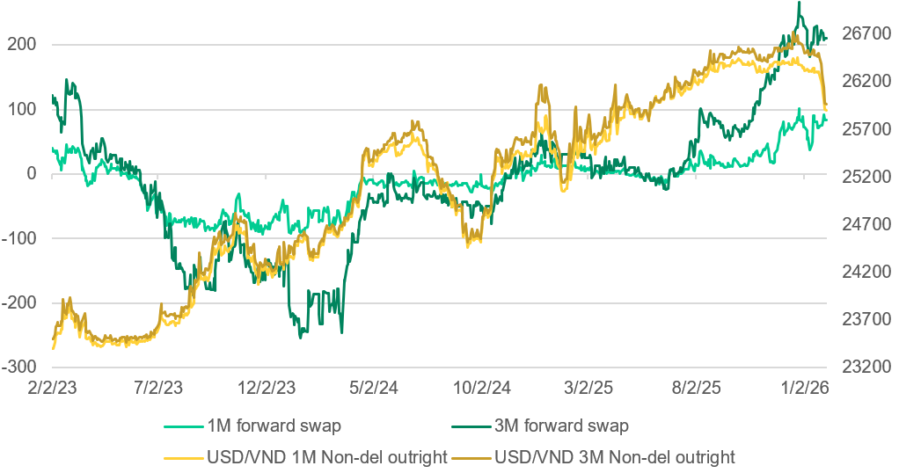
Source: NSO, International Monetary Fund (IMF) Source: NSO, International Monetary Fund (IMF)

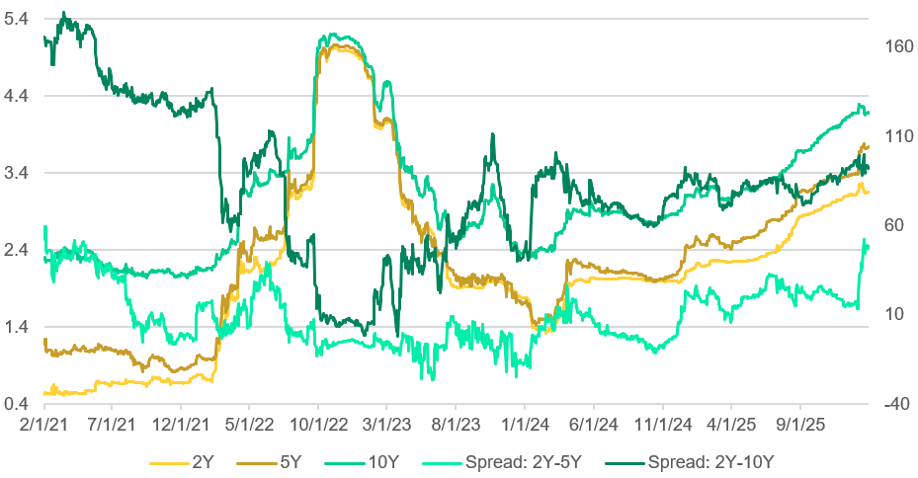

Figure 20: Repo rates (%) Figure 21: USD/VND official & unofficial FX fixings
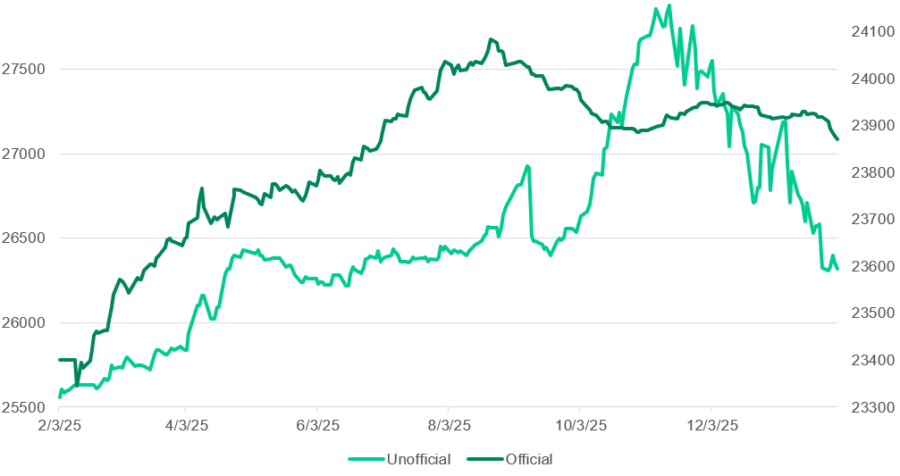
Source: LSEG Workspace Source: LSEG Workspace
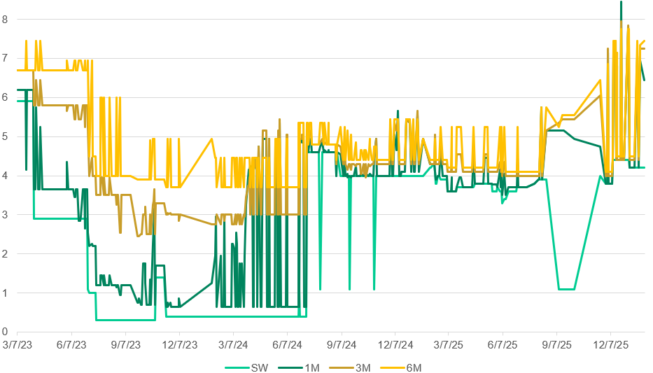

The evolution of Vietnam government bond yields and yield spreads suggests a gradual normalisation of domestic financial conditions after the post-pandemic easing cycle. While short- and medium-term yields have trended higher, the yield curve has remained broadly upward-sloping with no sustained inversion. This indicates that markets are pricing firmer funding conditions and higher term premia, but not an imminent growth shock or aggressive policy tightening. The behaviour of the 2Y–5Y and 2Y–10Y spreads further suggests that monetary policy transmission remains intact with longer-dated yields absorbing a greater share of macro uncertainty rather than policy sensitivity.

Looking at the SBV’s OMO framework, changes indicate a shift from accommodative liquidity support toward more active and selective liquidity management as external pressures intensified. Periods of low and stable interbank rates in 2020–2021 reflect abundant system liquidity and a policy stance focused on supporting growth following pandemic-related disruptions. As USD/VND pressures began to build from 2022 onward, repo operations became more frequent and rates more volatile, signalling SBV’s increased reliance on short-term instruments to fine-tune liquidity conditions. Notably, episodes in which interbank rates remained relatively anchored despite upward adjustments in policy corridor rates suggest that SBV has prioritised market functioning over signalling. Liquidity injections via repo operations appear to have been used tactically to offset FX-related liquidity drain, particularly during periods of heightened USD demand.

The juxtaposition of onshore FX swap rates and offshore USD/VND NDF pricing highlights persistent external pressure on the currency. Offshore markets have consistently priced USD/VND at a forward premium (especially at the 3-month horizon), thus signalling expectations of continued USD strength and regional FX headwinds. However, onshore 1M and 3M FX swap rates have remained relatively more contained and less volatile. Although there were periodic co-movements between onshore swaps and NDFs which point to episodic spillovers, these patterns appear to have not become entrenched and thus underscoring a degree of policy control over near-term liquidity. On the other hand, the divergence between official and unofficial USD/VND fixings provides an important behavioural and confidence signal. Periods of widening spreads such as Q42024 and Q42025 indicates episodic tightness in the cash FX market and precautionary USD demand among households and corporates, even when official rates remain relatively stable. However, the absence of a sustained or accelerating gap suggests that these pressures have remained somewhat contained.
Figure 22: Capital adequacy ratios (%)  Source: CEIC  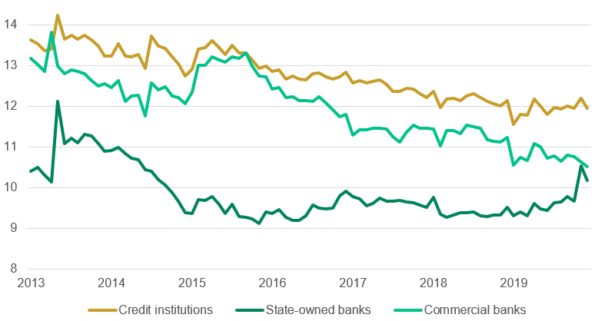  Figure 23: Outstanding private debt (VND trillion)  Source: AMRO, OECD  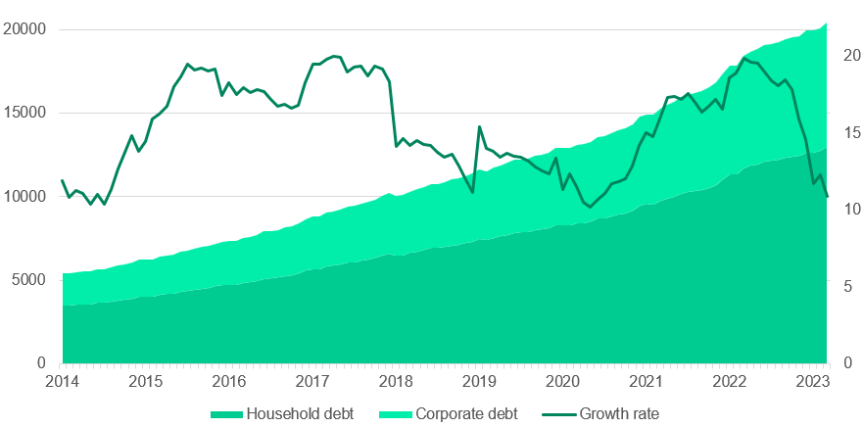  Figure 24: NPLs ratio  Source: CEIC  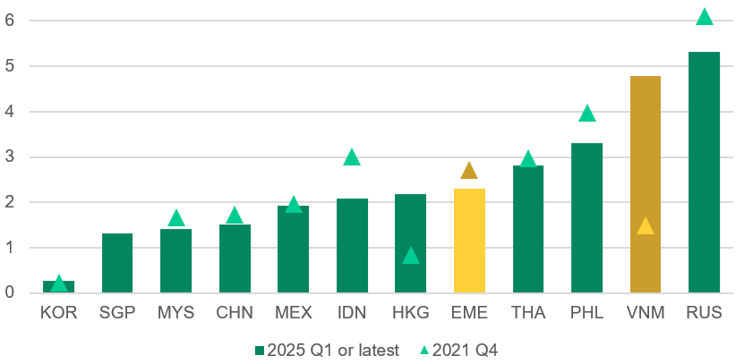  Figure 25: Shares of corporate sector debt (%)  Source: AMRO, OECD  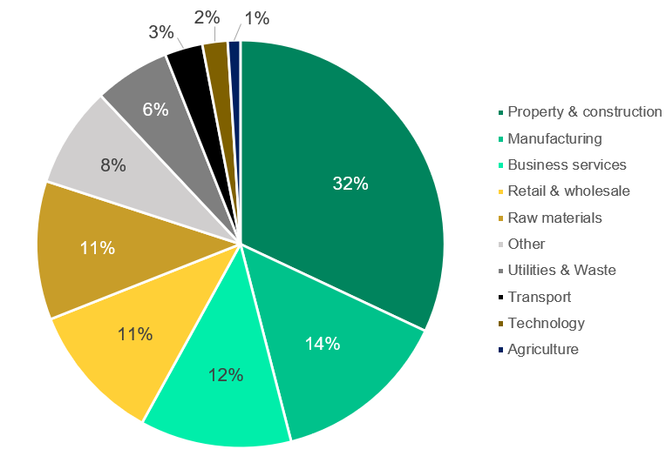 | The broad financial condition  Vietnam has a sophisticated set of monetary policy instruments - including policy interest rate, refinancing rate, credit growth ceilings for individual banks, interest rate caps on short-term bank deposits of up to 6 months, exchange rates, reserve requirement ratios, OMO and more. While emerging market economies tend to be vulnerable to external shocks, some studies suggested that with Vietnam’s current monetary policy framework, the impact of such external shocks on inflation and other aspects of the economy is likely to be smaller compared to a policy of relying solely on interest rates. (OECD, 2025)  Vietnam’s economic expansion has relied heavily on the availability of abundant and relatively inexpensive bank credit. By 2023, credit to the private sector had reached around 130% of GDP, well above the median for emerging market economies. Since 2013, outstanding private-sector debt has expanded at an average annual rate of around 15.5% and continues to elevate in 2024-2025, reflecting sustained credit deepening but also a growing dependence on leverage to generate growth. These vulnerabilities became evident as the highly leveraged corporate sector was hit by a sequence of adverse shocks, including the COVID-19 pandemic, the export downturn in 2023, and a severe correction in the real estate market. During the decade preceding the pandemic, rapid urbanisation and rising household incomes fuelled a property boom, with developers relying heavily on bank credit to meet surging housing demand. By 2022, around one-third of total corporate debt was concentrated in property and construction, making the sector a central node of systemic risk. (OECD, 2025) Apart from the concentration, what made this risk a systemic one stem from several amplification mechanisms. Firstly, property assets serve as a collateral across the banking system - meaning they anchor creditworthiness for developers, households and SMEs. When property prices decline, collateral values fall thus forcing banks to tighten credit.  The fallout from the property downturn has fed directly into banking-sector risks. Total non-performing loans (NPLs) rose from around 5.4% of total loans in early 2024 to over 7% by year-end, while on-balance-sheet NPLs doubled to 4.6% in late 2023 - the highest level in a decade. Bank capital buffers - although compliant with Basel II requirements remain relatively thin by regional standards, particularly among state-owned banks. More recently, however, improvements have been observed with NPLs ratio declining from its peak of 5.9% in September 2023 to 5.3% in March 2025; and banks’ capital adequacy ratios improved moderately to 10.4% for public banks and 12.1% for private banks. However, this improvement reflects a combination of regulatory forbearance, restructuring as well as selective resolution rather than a full normalization of borrower fundamentals. In addition, uncertainty surrounding the quality and valuation of SCB’s loan portfolio complicates restructuring efforts. To prevent systemic spillovers, the SBV has provided substantial liquidity support - estimated at around 5–6% of GDP through early 2024, while trying to limit excess liquidity across the broader banking system.

Figure 26: NPLs ratio to total loan outstanding Figure 27: Growth in corporate debt (%)
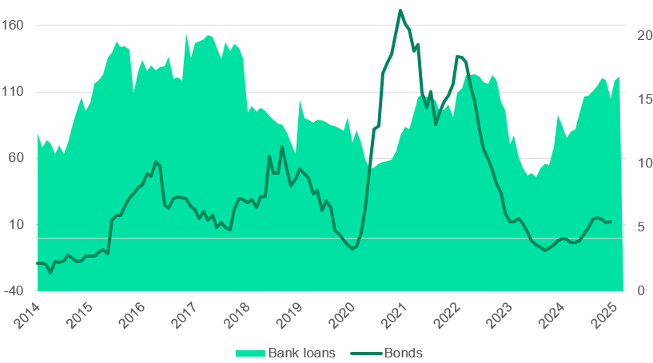
Source: SEF Research Source: FiinRatings, OECD
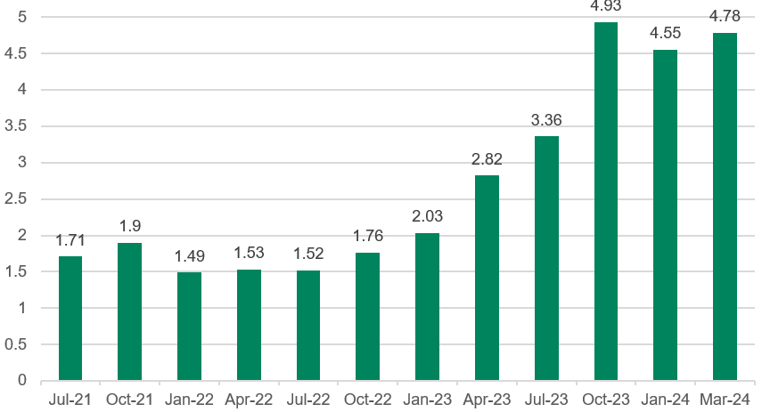

Implications for Investors

Due to the current FX volatility situation, the SBV’s commitment to keeping the USD/VND stable implies tighter domestic financial conditions than growth fundamentals alone would justify. For equity investors, this means that headline stability can mask a deteriorating multiple environment, as higher deposit rates (approaching or exceeding the 8% threshold) can trigger portfolio rotation away from equities and raise discount rates. For fixed-income investors, FX stability may reduce currency risk but does not entirely eliminate balance-sheet stress. This is because liquidity tightening would raise refinancing risks and increase dispersion across issuers - particularly among highly leveraged sectors. As a result, asset prices often weaken not during episodes of FX pressure itself, but during the subsequent phase of FX defence, when policy tightening bites most acutely.

When the SBV stabilises the dong, although the immediate macro signal may appear reassuring, the underlying financial transmission has materially different implications for asset pricing. In the current regime, VND exchange rate stability is not achieved through abundant FX reserves or strong external inflows but rather through tightening domestic financial conditions. This is typically achieved with higher deposit rates, episodic liquidity withdrawal via the interbank and OMO markets and selective administrative tightening. While these measures reduce FX volatility and limit balance-sheet stress for borrowers with foreign-currency exposure, they simultaneously raise the domestic risk-free rate and increase funding uncertainty across the economy. When deposit rates rise to defend the currency, the opportunity cost of holding equities increases sharply, particularly in Vietnam where retail investors account for a large share of market turnover and deposits are viewed as a relatively close substitute for equities. In response to funding stress and balance sheet risk, there may be higher equity risk premia which further depress valuation multiples. This repricing can occur even when reported earnings have not yet deteriorated as markets discount future cash flows more aggressively under tighter and less predictable financial conditions.

For Vietnamese banks, a stabilised dong produces a mixed but generally stabilising impact on profitability and balance-sheet quality. On the positive side, currency stability would reduce FX revaluation losses for banks with significant foreign-currency liabilities or open FX positions. For instance, large state-owned commercial banks such as Vietcombank and BIDV, which play a central role in trade finance and USD settlement for exporters, typically carry sizable foreign currency assets and liabilities. A stable exchange rate limits this volatility and also lowers the cost of rolling FX swaps and forwards used in liquidity and hedging operations. Regarding non-financial corporations, the benefits of this stability are similar as large conglomerates and capital-intensive firms such as Vingroup, Hoa Phat Group, and PetroVietnam Power have historically faced earnings volatility when the dong weakened, because FX translation losses appeared on income statements even when operating performance was unchanged. Furthermore, export oriented firms with USD-denominated liabilities such as electronics manufacturers or logistics firms engaged in cross-border trade are less exposed to sudden increases in debt-servicing costs when the dong is stable.

However, these benefits may be partly offset by the way FX stability is achieved. As mentioned above, higher deposit rates have a direct negative impact on bank profitability through net interest margins. As a result, banks that face rising funding costs without a sufficient increase in asset yields would experience near-term margin compression. This effect would be most pronounced among mid-tier and private banks which rely more heavily on competitive deposit mobilisation, while state-owned commercial banks (SOCBs) benefit from more stable funding bases and policy support. In addition, highly leveraged domestic firms face the clearest trade-off. Particularly, property developers, infrastructure and utilities benefit little from FX stability but bear the full cost of tighter domestic financial conditions. For these firms, revenues are earned mostly in VND therefore stable FX does not offset higher interest expenses and weaker credit access - thus making earnings and valuations more at risk.

Figure 28: Current account balance Figure 29: Financial account and Capital account balance
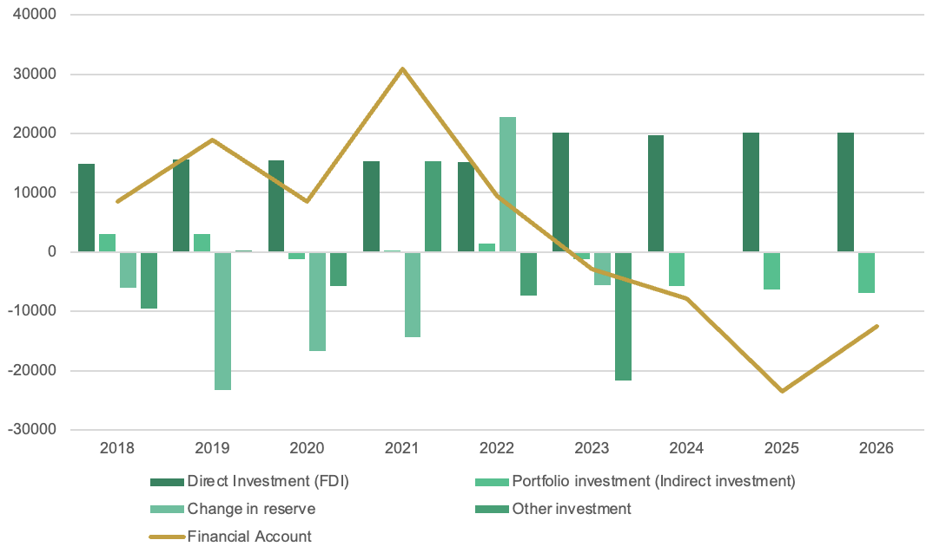
Source: NSO, International Monetary Fund (IMF) Source: NSO, International Monetary Fund (IMF)

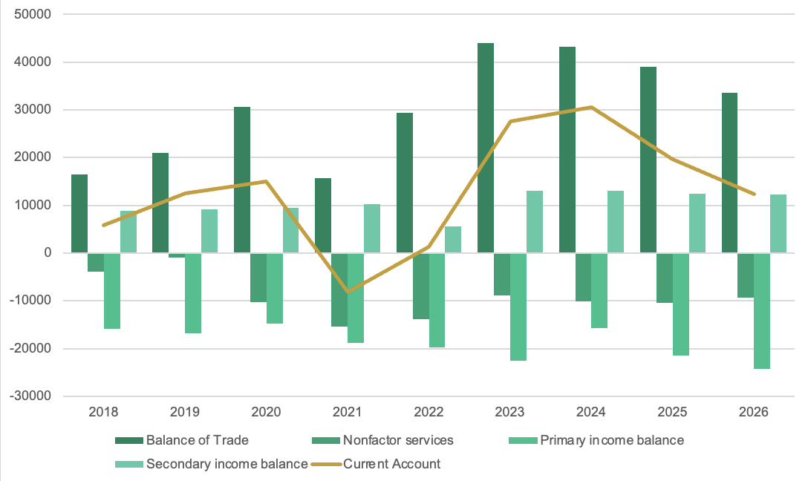

Annexes

Figure 30: Banks loan-to-deposit ratio (LDR %) Figure 31: International tourist arrivals (millions)
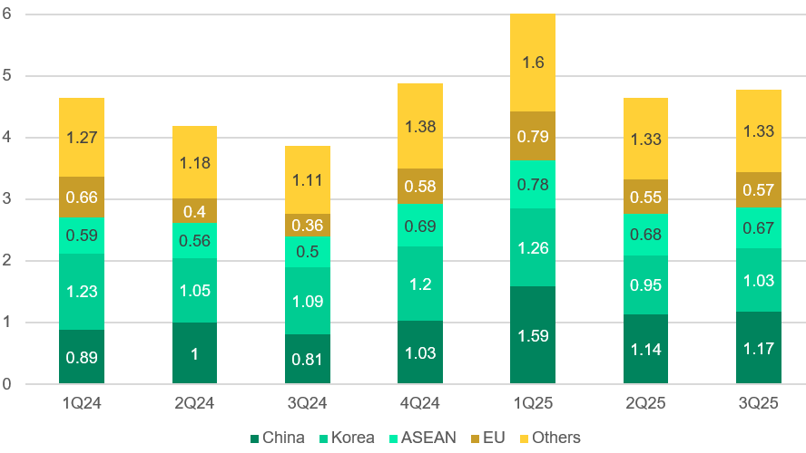
Source: SEF Research Source: NSO

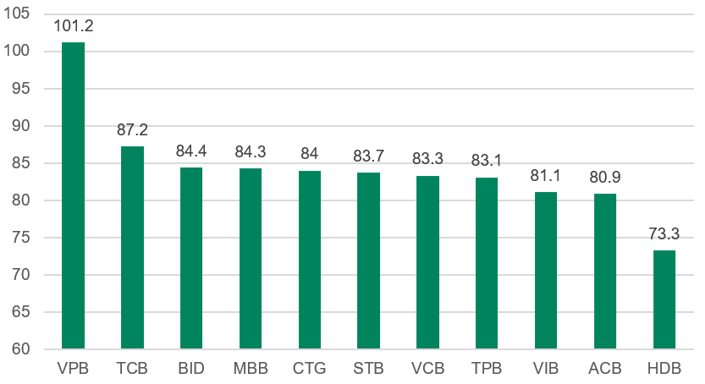

Figure 32: Credit growth by sector (% MoM) Figure 33: Contribution to GDP growth (%)
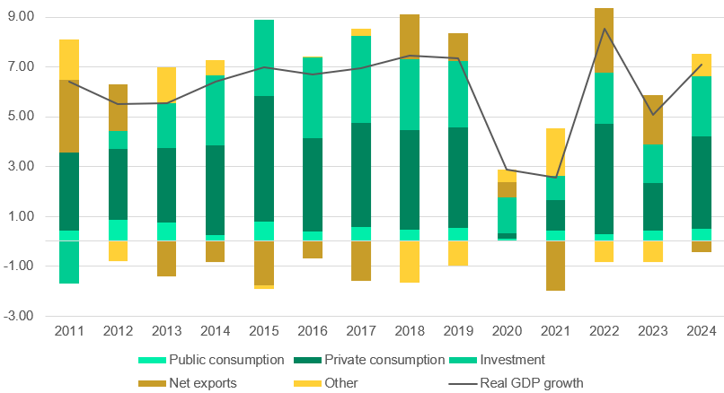
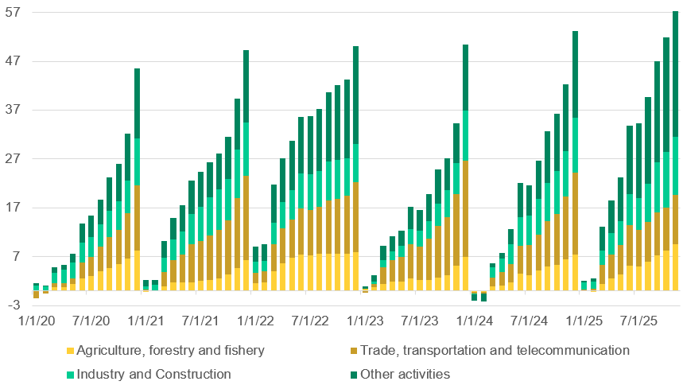
Source: LSEG Workspace Source: LSEG Workspace

Figure 34: SBV monetary policy instruments
Source: SBV, International Monetary Fund (IMF)

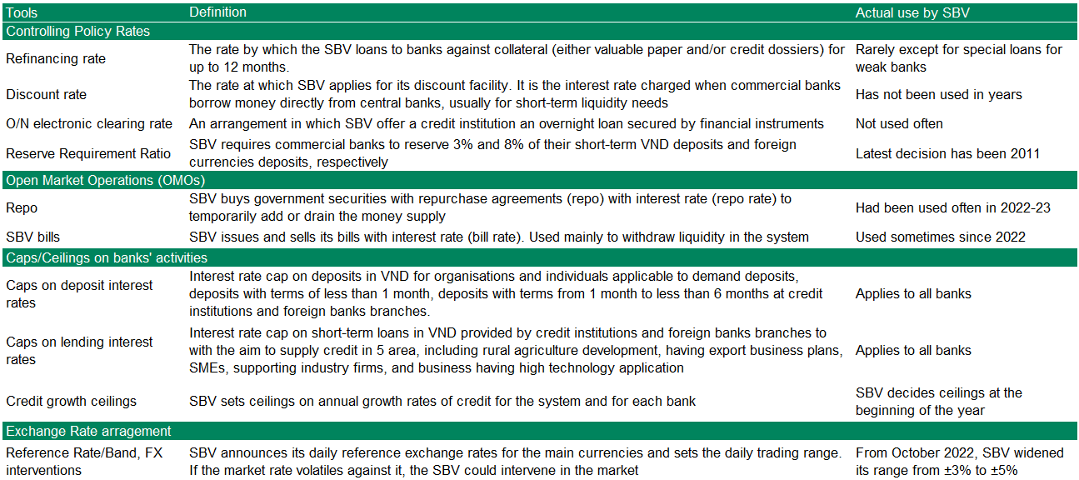

Disclosure
This report has been prepared by Saigon Equities Forum, a student collective solely for educational and informational purposes and intended for general circulation. The views expressed reflect the authors’ independent academic analysis and should not be regarded as genuine investment advice. The report does not necessarily reflect the opinions of Saigon Equities Forum as an organization.

The report does not follow specific investment goals, financial situation, or particular needs of anyone who may receive or read it. This report does not constitute an offer, nor a solicitation for one, to buy or sell any securities or option, futures, or other derivative instruments in any jurisdiction. This report does not constitute an advertisement for any financial instruments. Investors are warned to make independent decisions with regards to their financial situation or investment goals.

The information within was obtained through online sources believed to be reliable, and since it is not independently verified, SEF does not guarantee accuracy or completeness. Opinions, estimates, and projections shown in the report represent the views of the authors at date of publication and are subject to change without prior notice. Saigon Equities Forum carries no obligation to update, amend, or in any way modify this report or inform readers in the event that any subject matter, opinion, projection, or estimate changes or becomes inaccurate. Past performance is not an indication of future performance.

Readers should not make use of this report to violate any laws or regulations or subject Saigon Equities Forum and any of its affiliates to registration or licensing requirements in any jurisdictions that readers are in and make use hereof. Saigon Equities Forum and its affiliates do not accept any liability and loss arising from misuse of this report.

About Saigon Equities Forum
Founded in August 2025, Saigon Equities Forum is a non-profit, student-led initiative, dedicated to bridging knowledge gaps on the Vietnamese equities market and its role within the global financial system. Based out of Ho Chi Minh City, SEF consists of student researchers affiliated with renowned institutions across the world, united under one common purpose to study, analyze, and promote the Vietnamese financial and geopolitical landscape.

Our Team
Equity Research Director  Hung Tran  University of Amsterdam |  | Macro Research Director  Nam Nguyen  New York University |  | Senior Analyst  Tan Ngo  Marquette University
Analyst  Minh Tue Hoang  University of Melbourne |  | Analyst  Jay Chang  University of California, Berkeley |  | Analyst  Khai Son Vo  New York University
Analyst  Duy Nguyen  University of North Carolina, Chapel Hill |  | Analyst  Huy Ta  VinUniversity |  | Analyst  Sang Le  University of Finance - Marketing

© 2026 Saigon Equities Forum. All rights reserved. This report is produced for educational and research purposes. No part of this publication may be reproduced, or distributed in any form without permission.

Reference List
ASEAN+3 Macroeconomic Research Office. (2024). Vietnam 2023 annual consultation report: Special issue on corporate debt landscape.  https://amro-asia.org/wp-content/uploads/2024/04/Vietnam_2023-Annual-Consultation-Report_-SI-on-Corporate-Debt-Landscape-1.pdf  CEIC Data. (n.d.). Vietnam: Capital adequacy ratio.  https://www.ceicdata.com/en/indicator/vietnam/capital-adequacy-ratio  CEIC Data. (n.d.). Vietnam: Non-performing loans ratio.  https://www.ceicdata.com/en/indicator/vietnam/non-performing-loans-ratio  General Statistics Office of Vietnam. (n.d.). Banking, insurance, and state budget revenue and expenditure.  https://www.nso.gov.vn/ngan-hang-bao-hiem-va-thu-chi-ngan-sach/  General Statistics Office of Vietnam. (n.d.). Investment and construction.  https://www.nso.gov.vn/dau-tu-va-xay-dung/  General Statistics Office of Vietnam. (n.d.). National accounts.  https://www.nso.gov.vn/tai-khoan-quoc-gia/  General Statistics Office of Vietnam. (n.d.). Prices.  https://www.nso.gov.vn/gia/  General Statistics Office of Vietnam. (n.d.). Trade and services.  https://www.nso.gov.vn/thuong-mai-dich-vu/  International Monetary Fund. (2024). Vietnam: Selected issues.  https://www.imf.org/-/media/files/publications/cr/2024/english/1vnmea2024001-print-pdf.pdf  International Monetary Fund. (2025). Vietnam: 2025 Article IV consultation—Press release; staff report; and statement by the Executive Director for Vietnam.  https://www.imf.org/-/media/files/publications/cr/2025/english/1vnmea2025001-source-pdf.pdf | International Monetary Fund. (n.d.). World Economic Outlook database: Real GDP growth.  https://www.imf.org/external/datamapper/NGDP_RPCH@WEO/OEMDC/ADVEC/WEOWORLD  International Monetary Fund. (2022). IMF Working Paper: Risk spillovers and bank credit premiums in emerging Asia.  https://www.imf.org/-/media/files/publications/wp/2022/english/wpiea2022125-print-pdf.pdf  KPMG. (2024). Vietnam 2024 outlook: A Defining Moment for Growth. https://kpmg.com/vn/en/home/insights/2024/03/vietnam-economic-outlook.html  Organisation for Economic Co-operation and Development. (2025). OECD Economic Surveys: Viet Nam 2025.  https://www.oecd.org/content/dam/oecd/en/publications/reports/2025/06/oecd-economic-surveys-viet-nam-2025_f2511b78/fb37254b-en.pdf  Tuổi Trẻ Online. (2026). Tăng trưởng tín dụng năm 2025 hơn 19%, nhưng năm 2026 sẽ thấp hơn [Credit Growth in 2025 more than 19%, but 2026 will be lower].  https://tuoitre.vn/tang-truong-tin-dung-nam-2025-hon-19-nhung-nam-2026-se-thap-hon-20260110193917581.htm

